Project Functional Plan

Assessment 2

Kieran Abelen

Contents

Objectives 2

Test approach and assumptions 2

Features and Functionality to Test 3

Expected results of Test 4

Deliverables 4

Test documentation 4

References 5

Testing Plan Functional

# Objectives

* Test all Features
* Test all Transitions between Activities
* Must be able to exit each feature

# Test approach and assumptions

I need to test every planned feature and function of the program. This document will endeavour to lay out what those are and finally how I will go about testing them.  
What are the different features laid out a simple diagram  
Can every feature be reached and can every transaction between be achieved, can all features must be able to be exited.  
Finally once these have been tested can a user navigate the features to achieve a goal.

# Schedule

## Functional Testing

This will be don’t right after implementing any changed from the presentation on 1st Nov. this will most likely be on the 5th Nov

## Usability Testing

That same day I will plan times to do usability testing or even before if I’m able. 5th Nov onwards for user testing.

Functional Testing Procedures

## Intro

This will really make sure all the features work and all activities are accessible and exitible. Using a state transition model for showing and then listing all the activity/states. This will give me 100% functional coverage outside any nuances with a given feature.

## Methodology

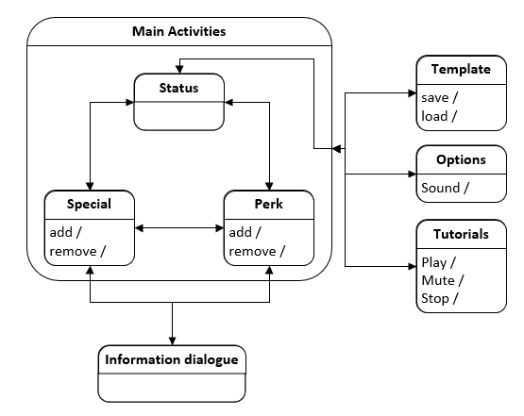

|  |  |  |  |  |  |  |  |
| --- | --- | --- | --- | --- | --- | --- | --- |
| Activity go to | Status | Special | Perks | Inform | Temp | Options | Tutorial |
| Status |  | X | X |  | X | X | X |
| Special | X | X | X | X | X | X | X |
| Perks | X | X | X | X | X | X | X |
| Inform |  | X | X |  |  |  |  |
| Temp | X |  |  |  | X | X | X |
| Option | X |  |  |  | X | X | X |
| Tutorial | X |  |  |  | X | X | X |

(Guru99)

# Usability Testing Procedure

## Introduction

This will test whether I have don’t a good job in designing my program to be easy to navigate and if the feature. I need to prepare the scenario and inform the user of any pertinent information. The test should be timed based on some criteria of achievement.

## Methodology

# Expected results of Test

|  |  |  |
| --- | --- | --- |
| Activity | Tests | Expected |
| Status | 1. Move all available activities | 1: Navigate to Special 1: Navigate to Perks 1: Open menu and go to Temp, Options, Tutorials |
| Special | 1. Move to all Available activities 2. Open extra information 3. Add or remove a perk | 2: Navigate to Status 2: Navigate to Perks 2: Open menu and go to Temp, Options, Tutorials 3: Open and information dialog box 4: Special can be added or removed, and page changes |
| Perks | 1. Move to all Available activities 2. Open extra information 3. Add or remove a perk | 5: Navigate to Status 5: Navigate to Special 5: Open menu and go to Temp, Options, Tutorials 6: Open and information dialog box 7: Special can be added or removed, and page changes |
| Information | 1. Information dialog can leave back to Special or Perks | 8: Exited to Special 8: Exited to Perks |
| Template | 1. Move to all Available activities 2. Save and load a template | 9: Exit to status 9: Open menu and go to Options, Tutorials 10: Save a template 10: Load a template |
| Option | 1. Move to all Available activities 2. Change volume 3. Mute sound | 11: Exit to status 11: Open menu and go to Temp, Tutorials 12: Lower volume and increase volume 13: mute sound, unmute sound |
| Tutorial | 1. Move to all Available activities 2. Pause or skip video 3. Mute sound on video | 14: Exit to status 14: Open menu and go to Temp, Options 15: Pause and skip, Play and Skip 16: mute sound and unmute sound |

# Usability Testing Procedures

# Deliverables

Three Testing scenarios

1. Moving to all available navigation options
2. Adding and removing special or perks.
3. Media skip, pause, mute and volume options.

# Test documentation

# References

Guru99. (n.d.). *What is State Transition Testing? Diagram, Technique, Example.* Retrieved from www.guru99.com: https://www.guru99.com/state-transition-testing.html